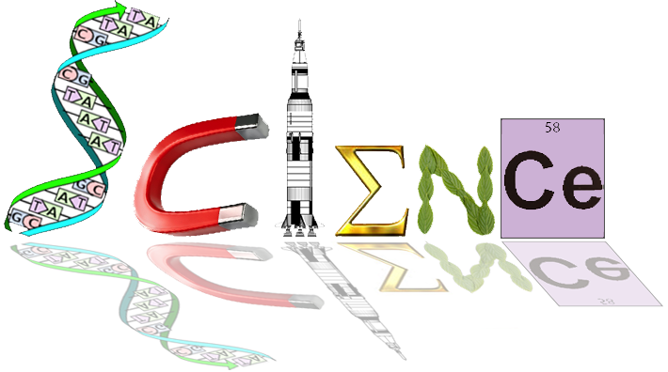

**12 HB Human Biology**

**ATHBY Unit 4**

**Task 7 – Evolution Test /58 marks**

**Part 1: Multiple Choice (15 marks)**

Question 1 refers to the following diagram of a phylogenetic tree:

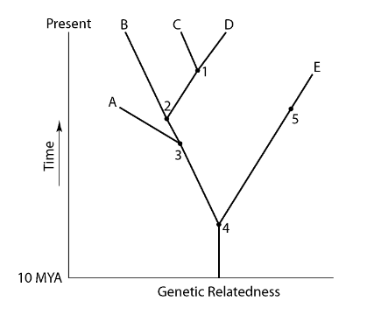

1. A common ancestor for both species C and E could be at position number

a) 1

b) 2

c) 3

d) 4

2. Fossilisation of soft tissues is **least likely** to occur in

a) the presence of decay bacteria.

b) sheltered conditions in a cave.

c) volcanic ash when organisms are smothered.

d) swamps under fine mud sediments.

3. Homologous organs:

a) suggest that the species **do not** share a common ancestor.

b) are a pair of chromosomes that contain genes that encode for the same structures.

c) are organs that have a similar structure but may have different functions.

d) are organs that have a similar structure and similar functions.

4. This question refers to the list of statements below.

(i) The fossil record has some specimens that show a gradual progression over an extended period of time to the present day.

(ii) The fossil record shows that some species have undergone no changes over time.

(iii) Protein analysis demonstrates that related species show much similarity in the sequence of their amino acids.

(iv) Vertebrates display a similar arrangement of their upper limb bones.

Which of the above statements provide evidence to support the theory of evolution?

a) (i) and (ii) only.

b) (i), (iii), and (iv)

c) (i) and (iv) 0nly

d) (i), (ii), (iii) and (iv)

Question 5 refers to the diagram below, which shows the sequences of rock strata from four locations.

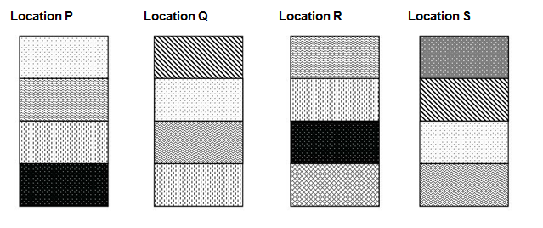

5. Which location appears to have the oldest stratum?

(a) P

(b) Q

(c) R

(d) S

6. All primates have:

(a) grasping hands, forward facing eyes and five digits.

(b) scent glands, stereoscopic vision and an enlarged cerebellum.

(c) ischial callosities, colour vision and a non-specialised body.

(d) tails, a reduced sense of smell and an enlarged cerebrum.

7. Australopithecine fossils have been found in:

(a) Africa.

(b) Africa and Asia.

(c) Africa and Southern Europe.

(d) Africa, Southern Europe and Asia.

8. Which of the following correctly lists the cultural advances of the hominin group in the most likely sequence of development (from earliest to most recent)?

(a) painting, use of fire, manufacture of simple stone tools, agriculture

(b) agriculture, painting, use of fire, manufacture of simple stone tools

(c) manufacture of simple stone tools, use of fire, painting, agriculture

(d) use of fire, painting, agriculture, manufacture of simple stone tools

9. Which of the following is NOT an adaptation to upright stance or bipedal locomotion?

a) The foramen magnum is located towards the back of the skull.

b) The heel bone is enlarged.

c) Vertebrae in the lower part of the spine are wedge-shaped.

d) The pelvis is broad and short.

10. Which of the following statements are true for Homo neanderthalensis?

(i) first hominins known to make use of fire

(ii) first hominins known to construct shelters

(iii) were efficient hunters of large animals

(iv) used flake tools to make clothes

(v) manufactured portable art depicting fertility symbols

Which of the above statements are correct?

(a) (i) and (iii) only

(b) (i), (ii) and (iv) only

(c) (iii), (iv) and (v) only

(d) (iii) and (iv) only

11. The term ‘carrying angle’ refers to the

(a) forward tilt of the body of most primates during bipedal or quadrupedal locomotion.

(b) angle created between the long axis of the femur and the vertical.

(c) orientation of the foramen magnum to the vertical axis of the skull of most primates.

(d) forward tilt of the pelvis during bipedal locomotion.

Questions 12 and 13 refer to the lower jaw diagrams shown below.

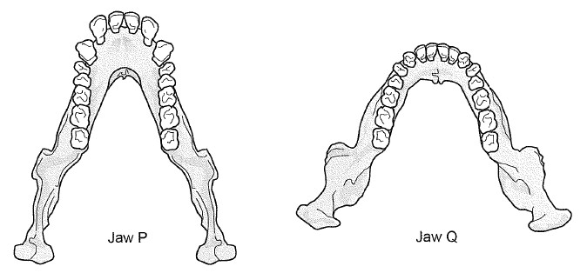

12. Which of the following statements about the lower jaws shown in the diagrams is correct?

(a) Jaw P belongs to a modern human because the dental arcade has a parabolic shape.

(b) Jaw Q belongs to a great ape because the teeth are of an even size.

(c) Jaw P belongs to a great ape because of the presence of a diastema.

(d) Jaw Q belongs to a modern human because there are more molars present than in Jaw P.

13. If the complete skeleton of the specimen belonging to Jaw Q was examined, which of the following characteristics would it be expected to have?

(a) longitudinal and transverse arches of the foot

(b) small outer condyle of the femur at the knee joint

(c) only one curvature of the vertebral column

(d) bowl shaped pelvis that is long from top to bottom

Questions 14 and 15 refer to the stone tools shown below.

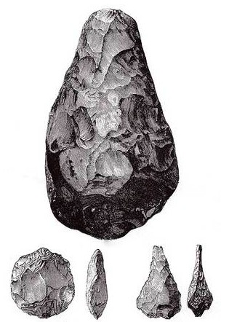

14. To which tool culture do the tools shown above belong?

(a) Oldowan pebble tools

(b) Acheulian hand axes

(c) Aurignacian blade tools

(d) Magdalenian barbed spears

15. What cultural advance would also be associated with the group of individuals responsible for making the stone tools shown above?

(a) construction of murals and portable art

(b) beginning of farming practices

(c) evidence of rituals and burial of the dead

(d) beginning to use fire

**YEAR 12 ATAR HUMAN BIOLOGY**

**Task 7: Evolution Test**

**NAME:_____________________________**

**TEACHER:__________________________**

**DATE:______________________________**

**Multiple choice section**

Answer all questions by placing an X over the most correct answer on the multiple choice answer sheet.

1. a b c d 11. a b c d

2. a b c d 12. a b c d

3. a b c d 13. a b c d

4. a b c d 14. a b c d

5. a b c d 15. a b c d

6. a b c d

7. a b c d

8. a b c d

9. a b c d

10. a b c d

SCORES:

MC: /15

SA: /37

EA: /10

TOTAL: /62

**Part 2: Short Answer (35 marks)**

16. Explain how the study of comparative DNA can provide evidence for evolution. (2 marks)

* Even species that seem to be different actually have large sections of identical DNA
* How closely or distantly species are related is based on the amount of difference in DNA

17. Use the table below to answer parts (a), (b) and (c).

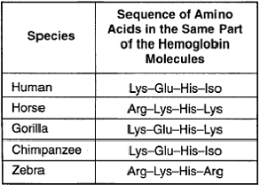

a) The specific type of study shown above is used to provide evidence for evolution. Name this type of study and describe how it provides evidence for evolution. (2 marks)

* Proteomics / Comparative studies in biochemistry/protein analysis
* The more similar the amino acid sequence in proteins of two species, the more likely they are to have diverged from a common ancestor

b) Explain how the study of ubiquitous proteins can provide evidence for evolution. (2 marks)

* Cytochrome c and haemoglobin are compared to determine the relationship between two species
* Cytochrome c is a small protein that plays an important role in the electron chain within mitochondria of all cells
* An analysis of cytochrome c shows the similarities and differences between species

c) Using the table above, explain the evolutionary relationship of the human to the horse compared with the human to the chimpanzee. (2 marks)

* Human & chimpanzee have identical amino acid sequence in their haemoglobin molecules
* Human & horse share one common amino acid in their haemoglobin molecules.
* Therefore human and chimpanzee are more closely related

18.Complete the table below, describing the evolutionary trends that occur within the family Hominidae. (3 marks)

|  |  |
| --- | --- |
| **Characteristic** | **Evolutionary trend** |
| Mobility of digits of the hand | Pentadactyl: 5 digits on each limb  Digits can be moved independently of one another thus increased mobility |
| Prognathism | Apes have flattened nose but more pronounced prognathism  Whilst the rest of the face has flattened & less prognathism, the nose has not |
| Size of molar teeth | Molar becomes smaller  Lower molars have 5 cusps forming Y-5 pattern |

19.To determine the sequence of changes in living things over time, fossils undergo a dating process. Certain processes are more suitable for some fossil types and not others. (5 marks)

1. Complete the below table comparing and contrasting dating techniques (3 marks)

|  |  |  |
| --- | --- | --- |
|  | **Dating Techniques** | |
| **Type of Technique** | Relative dating | Absolute Dating |
| **One Example** | Stratigraphy, Fluorine Dating | Potassium-Argon Dating |
| **Underlying principle** | Comparative | Radioisotope decay |

1. A scientist was studying a new field of fossils. The fossils close to the surface were successfully dated using Carbon-14 dating, but the age of the lower down layers containing volcanic rocks could not be determined using the carbon in the fossils. At no time in the past had this field of fossils been exposed to water sources.

Predict which specific absolute dating technique would be useful to the scientists, and explain how this technique can only be used to provide a relative date for the fossils in the older layers.

(2 marks)

Technique: Potassium Argon Dating (1)

Explanation: PA Dating would give an absolute age for the volcanic rocks in the lower strata. These rocks would then give a relative age for the fossils in the same strata layer. (1)

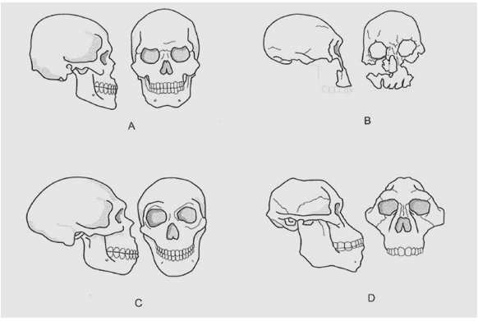20. Parts (a) and (b) of the question refer to the hominin skull diagrams A, B, C, and D shown below.

a) Place the skulls A, B, C and D in the correct evolutionary sequence, from oldest to most recent.

D, B, C, A (1 marks)

b) Describe the evolutionary trend that can be seen in hominin fossils associated with the jaw. Explain why this trend is believed to have occurred. (2 marks)

* Smaller teeth /reduced jaw muscle associated with a change in diet from herbivorous to omnivore
* Change from ‘U’ to parabola shaped jaw / reduced size in molars associated with moved towards cooked / softer food
* Chin – increased size to allow for attachment of muscles used in speech

c) Describe the general trend in the evolution of hominin teeth and describe cultural factors that may have influenced this trend. (3 marks)

* Smaller teeth
* Loss of prominent canine and diastema
* use of fire to cook roots and tubers
* hunting for meat

d) What features of a fossilised skeleton would clearly indicate the individual was bipedal? (3 marks)

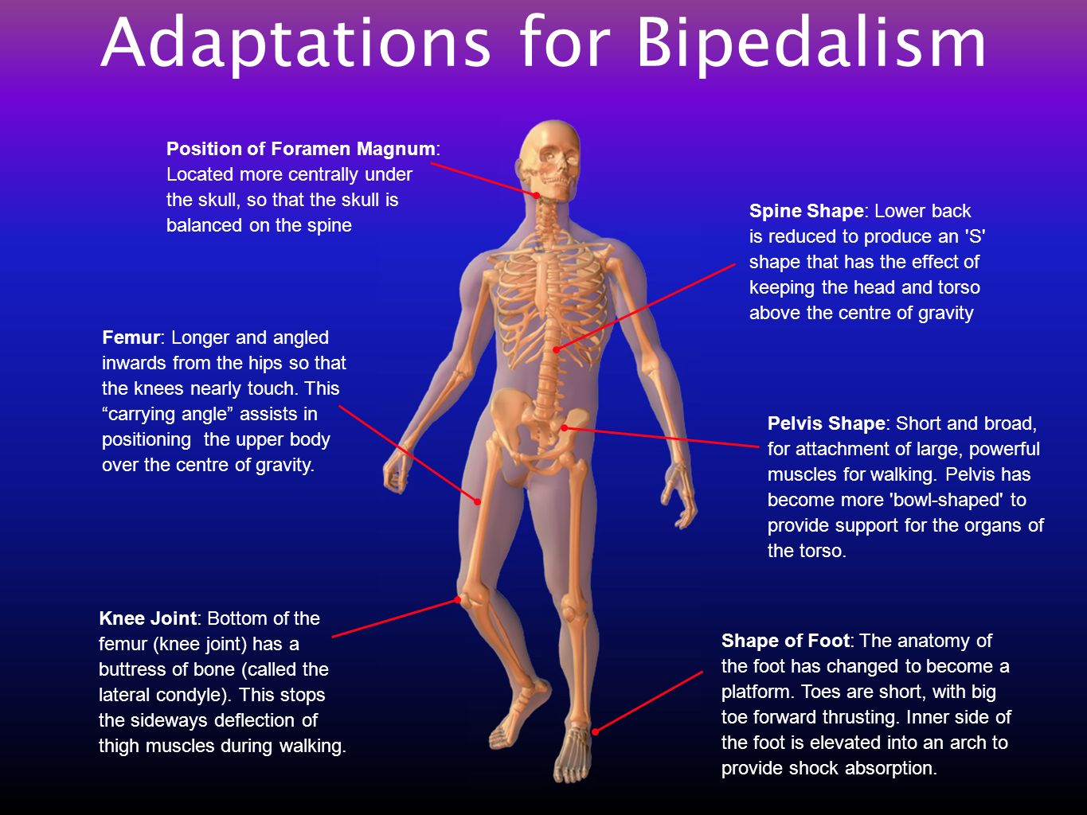

21. (a) Name the hominin that was the first to; (3 marks)

(i) use fire ___H. Erectus_

(ii) use ritual burial _______H.Neanderthalensis___

(iii) domesticate animals _____H. Sapien__________

b) Name the hominin that produced the art forms shown in this diagram. (1 mark)

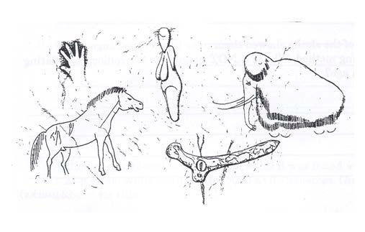

Cro-Magnon man

c) For each of the following (C1 to C4) identify the tool culture and the associated hominin group.

(4 marks)

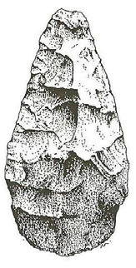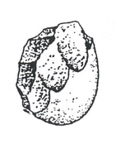

Tool culture____Acheulean______________ Tool culture__Oldowan

Hominin _____H.erectus or heidelburgensis______ Hominin ___Australopithecine/H habilis

Hominin _____H.erectus or heidelburgensis______ Hominin ___Australopithecine/H habilis

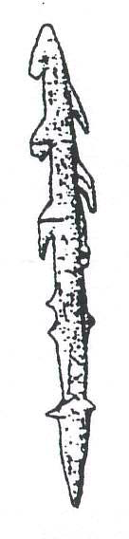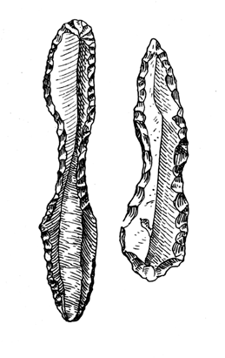

Tool culture___Mousterian_________ Tool culture___Magdalenian ______

Hominin __H. neanderthalensis_____ Hominin ___Cro-Magnon__________

(4 marks)

d) When anthropologists place the above tools in date order, clear trends are obvious. Naming one specific trend, link it to an anatomical trend to explain how hominin species were able to achieve the trend.

(2 marks)

1 mark for trend name – eg materials (stone to bone), manufacturing techniques

1 mark for explanation –

Anatomical trends *Increasing cranial capacity* allowed greater forward planning and visioning of the

potential use of materials that were formally thought not useful.

*Increasing opposability of thumb and/or increasing digit mobility* allowed greater/finer

working of tools for increasing specialisation of tool use

22. The diagram below shows a phylogenetic tree of present-day hominids. The numbers in ovals at the branch points indicate the percent DNA similarity with humans.

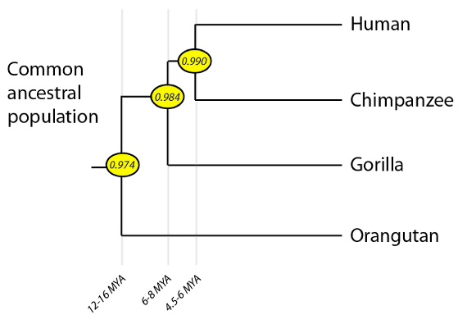

On the basis of the information contained in the phylogenetic tree, are Humans more closely related to Gorillas or Orangutans? Explain your answer. (2 marks)

More closely related to Gorilla (1)

with 98.4% DNA similarity (1)

**Extended Answer (10 Marks)**

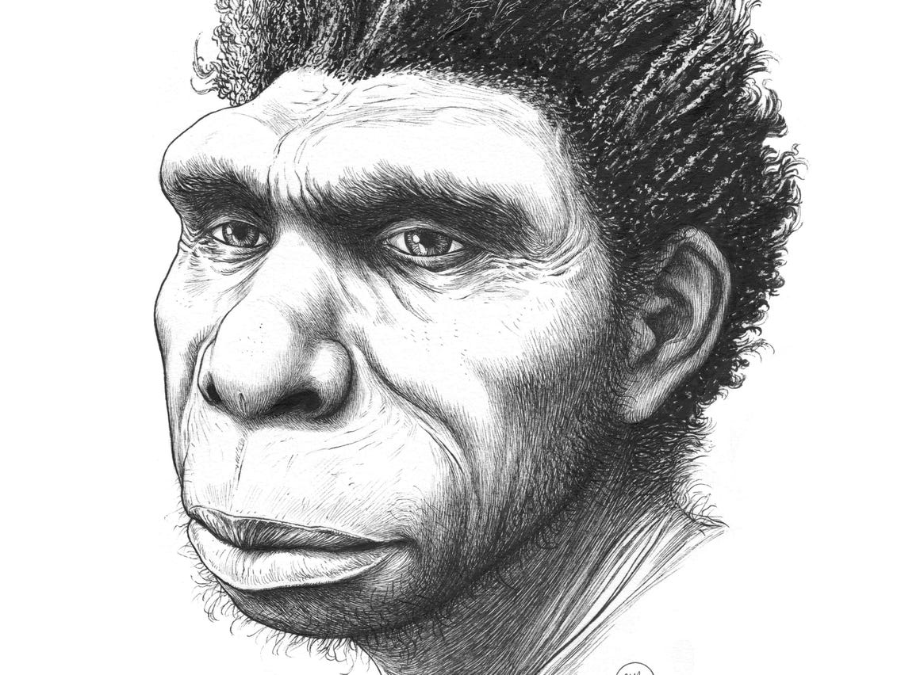

Archaeologists discovered an almost complete hominid specimen in Bodo D’ar in the Awash River valley of Ethiopia. The fossil was dated at approximately 500,000 years old and named *Homo bodoensis*. Initially archaeologists did not know whether the specimen belonged to *Homo neanderthalensis* or the direct ancestor of modern *Homo sapiens*. With more detailed inspection of the skeletal characteristics it was decided the specimen was the direct ancestor of modern *Homo sapiens*.

a) Describe the steps involved in the evolutionary process that leads to the development of *Homo sapiens* from *Homo bodoensis*. (7 marks)

*One mark for key word (bold) and one mark for matching description.*

*Answer must make sense and be in order.*

**VARIATION** – there is genetic variation within a species   
Sapien and Bodoensis shared a common ancestor that lived 800,000 years ago in Africa

**ISOLATION** – Organisms are geographically isolated from each other   
Common ancestors originated from Africa then migrated to Europe

**COMPETITION** – individuals compete for scarce resources

**SURVIVE** – those most able to use resources survive the most   
Those individuals with Sapien features were most able to survive.

**REPRODUCE** – those most able to survive produce the most offspring   
Sapiens produced more offspring than Bodoensis and more sapien offspring went on to reproduce

**MOST FIT** – those that produce the most offspring are the most fit

**SPECIATION** – the genes of the most fit become most common, and differences accumulate over time that lead to a new species   
Individuals with Sapien features became most common.

b) Describe three features of the post-cranial skeleton (parts of the body that lie posterior to the head) that would allow scientists to distinguish a fossil as *Homo neanderthalensis* (3 marks)

*Any three features as listed*

